Software Requirements Specification
for
Brew Day
Version 5.0 approved
Prepared by Yuanzhen Lin, Xiaochen Xu, Ziqi Wang, Weifeng Huang
Gray
2019/03/12
Table of Contents
1. Introduction 1
1.1 Purpose 1
1.2 Document Conventions 1
1.3 Intended Audience and Reading Suggestions 1
1.4 Project Scope 1
1.5 References 1
2. Overall Description 2
2.1 Product Perspective 2
2.2 Product Features 2
2.3 User Classes and Characteristics 2
2.4 Operating Environment 2
2.5 Design and Implementation Constraints 3
2.6 User Documentation 3
2.7 Assumptions and Dependencies 3
3. System Features 3
3.1 Maintaining recipe 3
3.2 Maintain Ingredient 4
3.3 Recommend a recipe 5
3.4 Write Note 6
3.5 Maintain equipment information 7
4. External Interface Requirements 8
4.1 User Interfaces 8
4.2 Hardware Interfaces 11
4.3 Software Interfaces 11
4.4 Communications Interfaces 11
5. Other Nonfunctional Requirements 11
5.1 Performance Requirements 11
5.2 Safety Requirements 11
5.3 Security Requirements 11
5.4 Software Quality Attributes 12
6. Other Requirements 12
7. Other Requirements 12

Revision History
Name | Date | Reason For Changes | Version
SRS_Gray_1.0 | 3.05.2019 | Initial Version | 1.0
SRS_Gray_2.0 | 3.12.2019 | Second Version, adding 2 features and UI | 2.0
SRS_Gray_3.0 | 3.19.2019 | Third Version, all features and UI | 3.0
SRS_Gray_4.0 | 3.26.2019 | Fourth Version, class diagram, sequence diagram for add ingredient | 4.0
SRS_Gray_5.0 | 4.2.2019 | Final version | 5.0

Introduction

Purpose
The purpose of this document is to give a detailed description for the requirements of “Brew Day” software. It will illustrate the purpose of this software, the design and implementation of the system. It will contain product features, system constraints, interface, and intended readers. The security problems and other requirements will also be included.

Document Conventions
The main body of this document will be written in font Times, size 12. The title will be in Times, font size 14 or 18 in bold. Priorities for higher-level requirements are not assumed to be inherited by detailed requirements, every requirement statement have its own priority.

Intended Audience and Reading Suggestions
The rest of this document will describe features of the software, classes of different users, environment while implementation and some constrains in Section 2. The details of user features are illustrated in Section 3; external interface and security problems are shown in Section 4 and 5. Section 6 includes some complementary requirements. The appendixes are listed at the last of this document.

The intended audiences for this document are people who design the software: software developers, client engineers, and system architects. And also, for people who do not need to know much details about the design: Project manager, End-users, Client, and Contractor, who are recommended only to read Section 1, 3, 5 of this documentation.

Project Scope
The purpose of this software “Brew Day” is to develop an application for home brewers that allows them to maintain a list of recipes and adapt existing ones. The beer enthusiasts or people who interested in brewing beer will be able to log their notes about brewing, maintain an updated list of available ingredients, and do other activities. The details of the features will be included in section 2.2 and 3 of this document.

References
Siebenthal, C.(2019).Learn the Step-by-Step Process Of Brewing Beer, Explained in Animated GIFs. Retrieved from https://firstwefeast.com/drink/learn-how-to-brew-with-these-fun-animated-gifs

Overall Description

Product Perspective
This is a new product, so there is nothing to be referred.

Product Features

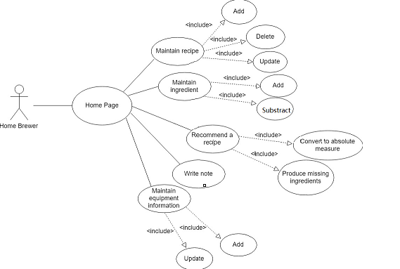

User Classes and Characteristics
The main user classes for this product is the home brewers, who prefer to brew at home and produce beer on a small scale for personal purposes. As a home brewer, they often own a brewing equipment and brewing capacity as well as the required ingredients for brewing at home. Thus, the product will provide the function to help the users to maintain a list of recipes, adapt existing ones and update list of available ingredients according to their corresponding resources.

Operating Environment
The software is operated under the standalone Windows operating system.

Design and Implementation Constraints
This is a desktop-based application and JAVA language is used.

User Documentation
TBD.

Assumptions and Dependencies
The software will use JAVA JDK for development, so the users are assumed to install the JDK in their environment.

System Features

Maintaining recipe
    - Description and Priority
For this feature, a high priority feature, users can add a new recipe to the database with the specific use of ingredients, water and equipment, procedure and time to implement the recipe.

Also, users can delete the current recipe if they want.

Last, users can update and modify the ingredient composition, procedure and time for the existing recipe. For example, they could increase and decrease the amount of the ingredient, or add the time needed for brewing.

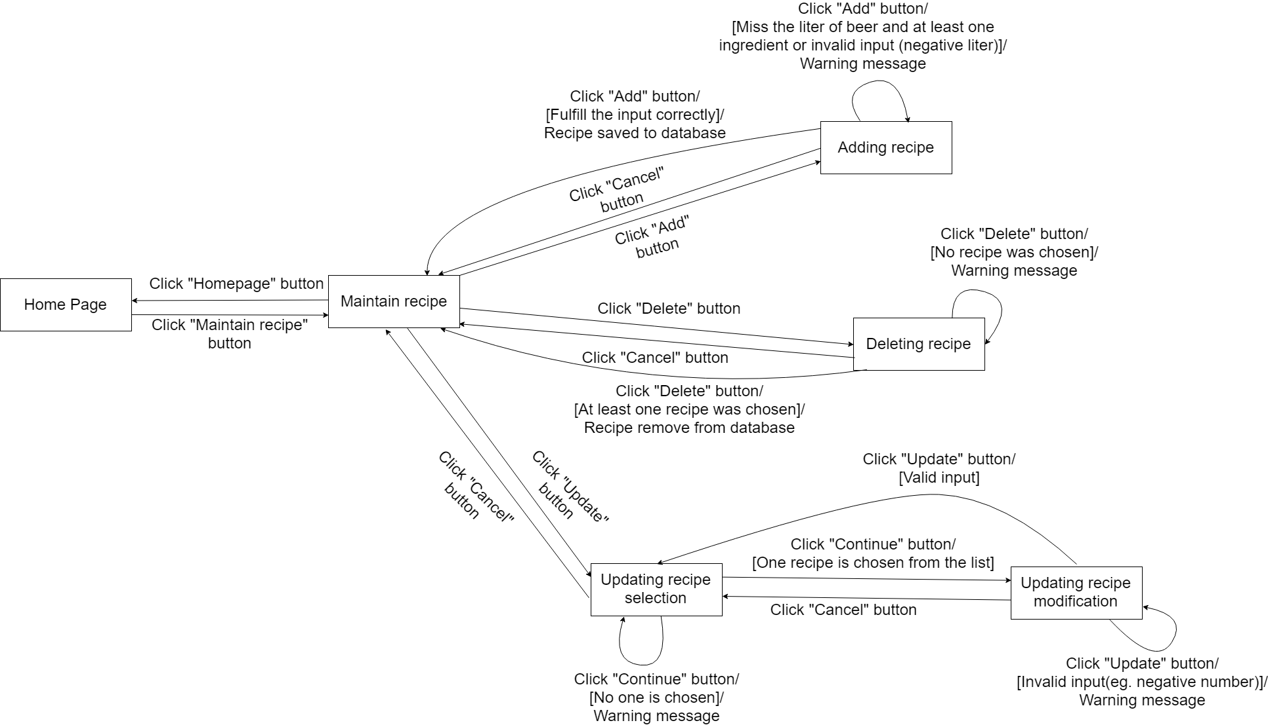
    - Stimulus/Response Sequences

3.1.3 Functional Requirements

REQ-1: When adding a new recipe, if the input bar is all blank, then a warning message will show out when the user clicks the ‘add’ button.

REQ-2: When deleting an existing recipe, as the user click the ‘delete’ button, a waring message will be showed out to remind the users to assure the action.

REQ-3: When updating an existing recipe, if the user input nothing, then a warning message will show out when the user clicks the ‘update’ button. If the user decreases some ingredients below 0, then a warning message will show out when the user clicks the ‘update’ button.

Maintain Ingredient
3.2.1 Description and Priority
This feature has the highest priority.
Every user is required to input some ingredients, whose actual amounts vary from recipe to recipe. The system is able to add ingredients which not exist (not been added to the system) before. The user is able to update the amount of this ingredient once he or she adds it to the ingredients list.

The system is also able to update the available ingredients list. When the user brew and us a certain number of gradients, the system will subtract used ingredients from the available ones. When the user buys ingredients, the available ingredients list will be updated and added the purchase quantity to the existing ingredient.

3.2.2 Stimulus/Response Sequences
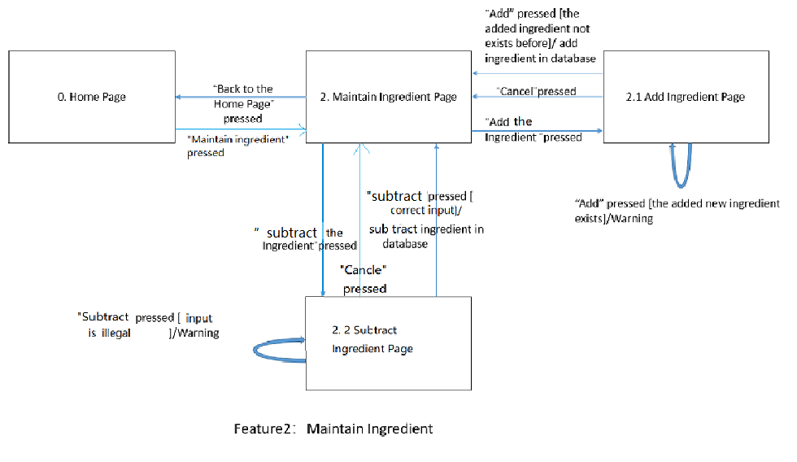

3.2.3 Functional Requirements
REQ-1: When adding the amount of an ingredient, if the input bar is all blank, then a warning message will show out when the user clicks the ‘add’ button.

REQ-2: When subtracting the amount of an ingredient, if the user input nothing, then a warning message will show out when the user clicks the ‘subtract’ button. If the user decreases some ingredients to below 0, then a warning message will show out when the user clicks the ‘subtract’ button.

Recommend a recipe
    - Description and Priority

This feature is in highest priority. This feature will base on the ingredients the user has and to recommend the user a recipe.
At first, we need the user input how much they want to brew.

The software will Convert ingredients into absolute measure base on the recipes, calculate the total ingredients we need, match the recipe in the database, compare the ingredients we have and get the missing ingredients. Which that we can get the recipe.

The recommended recipes are listed in the recommend page, the recipe which lack of some ingredients will also list below the recommended recipes, and each recipe will be noted the ingredients they lack.
This feature will compare the ingredients we have to the ingredients in the recommended recipe. If we have lack of any ingredients this feature will show the missing ingredients.

    - Stimulus/Response Sequences
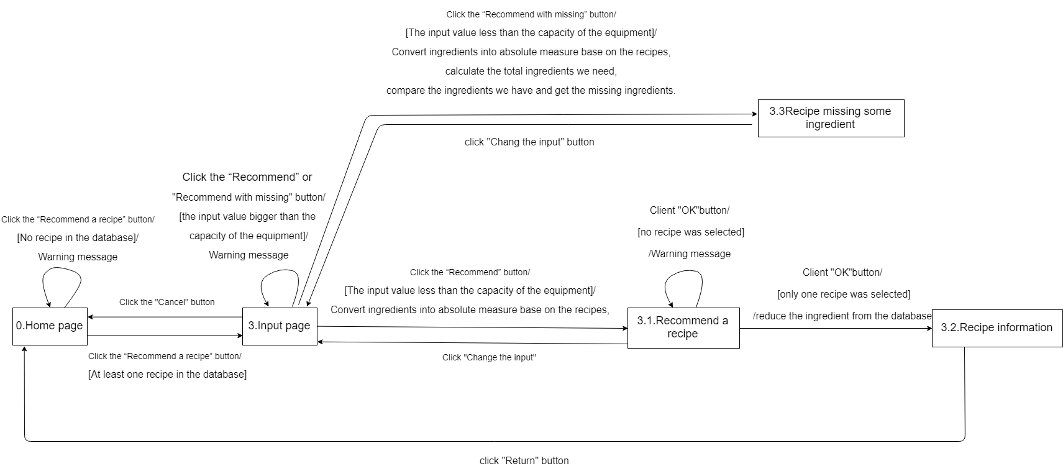

    - Functional Requirements

REQ-1: When we need to be recommended a recipe. If we don’t have any recipes in the database, it will give a warming, and jump back to the main page.

Write Note
3.4.1 Description and Priority
This feature has the middle priority.
The system is supported for user to write notes on brews. And there is a particular kind of note is the tasting note, which allows brewers to keep track of opinions on a beer from a particular brew.

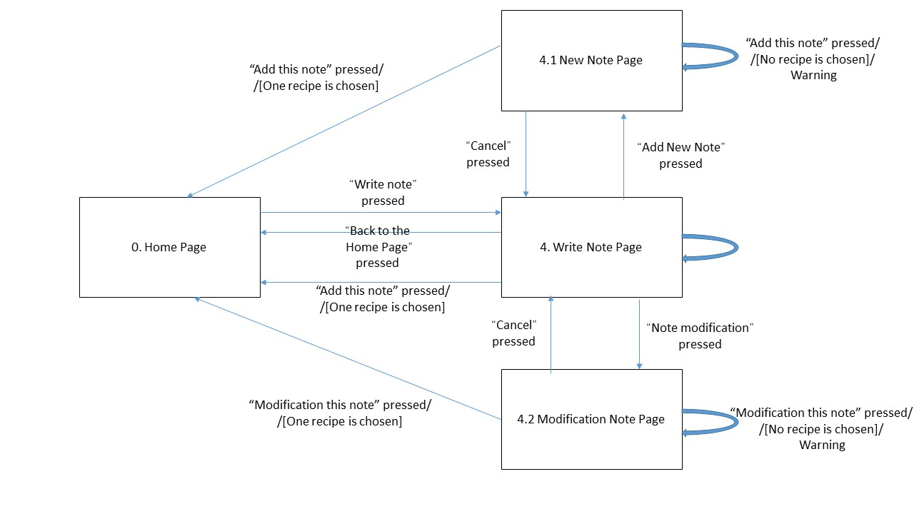
3.4.2 Stimulus/Response Sequence

3.4.3 Functional Requirements
REQ-1: When writing a note, if the input bar is all blank, then a warning message will show out when the user clicks the ‘Add this note’ button.

Maintain equipment information
3.5.1 Description and Priority
This feature has the highest priority.
Every home brewer owns a brewing equipment (kettles, fermenters, pipes, etc.) with a certain maximum brewing capacity, the number of liters the equipment is able to handle in a single "batch". And whet the user has a new equipment or updates his/her equipment, he or she will be able to update the new maximum brewing capacity.
3.5.2 Stimulus/Response Sequence

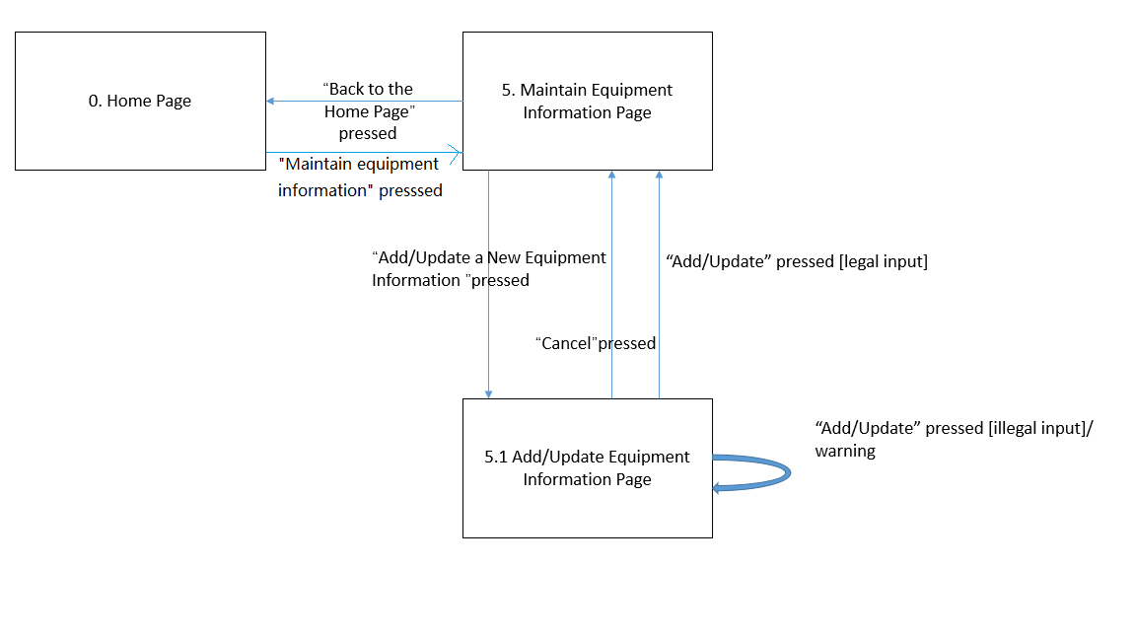
3.5.3 Functional Requirements
REQ-1: When adding or updating the equipment information, if the input is illegal (blank or no number included) then a warning message will show out when the user clicks the ‘Add/Update’ button.

External Interface Requirements

User Interfaces
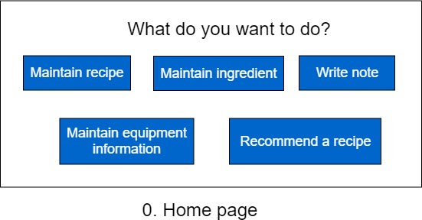
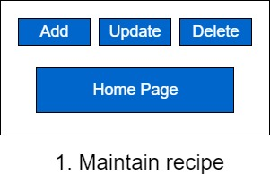

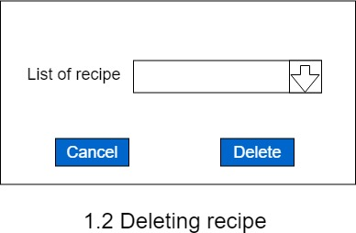

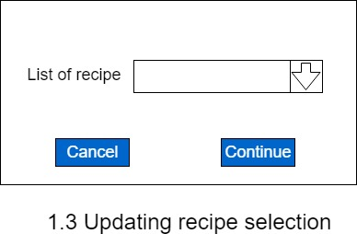

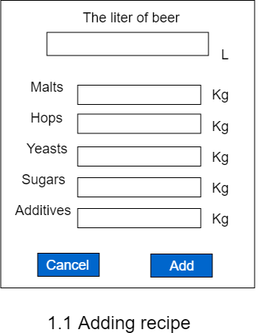

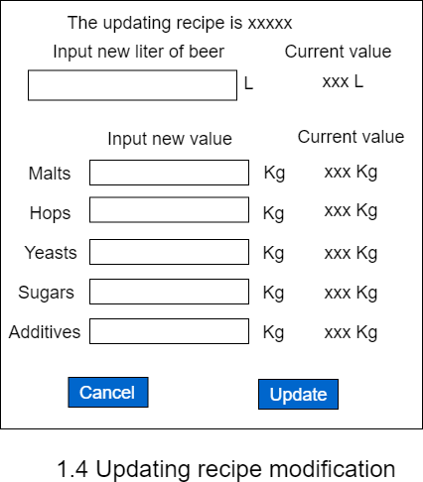

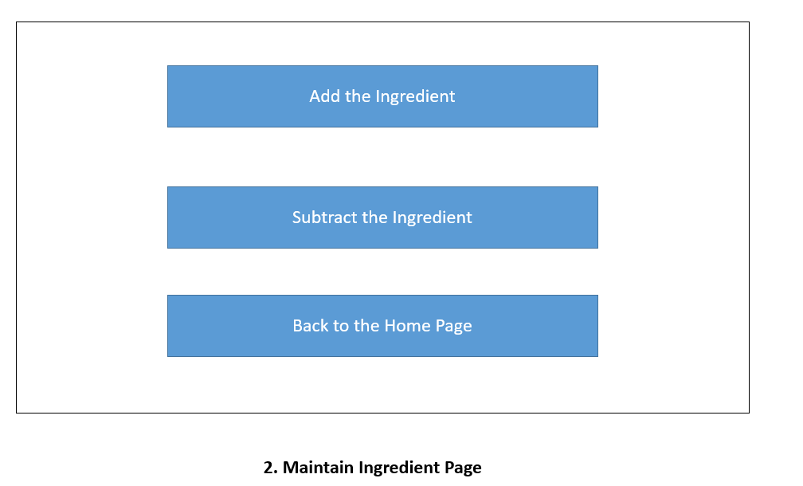

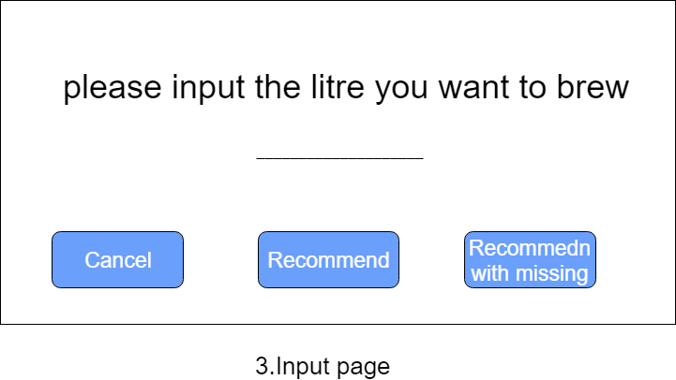
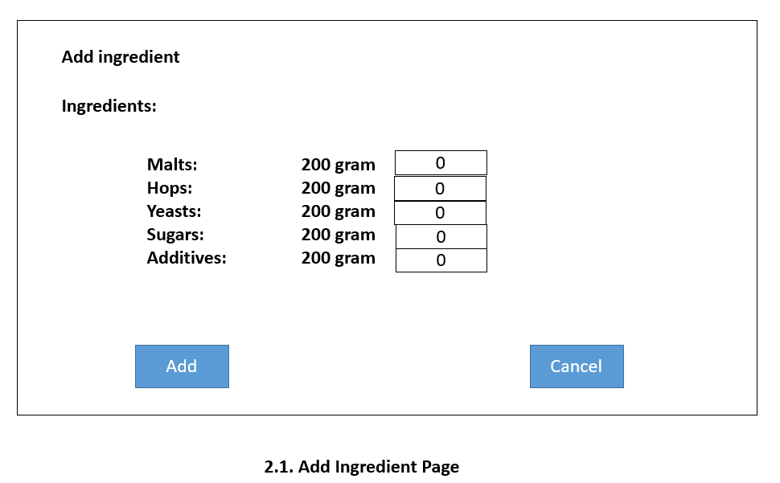

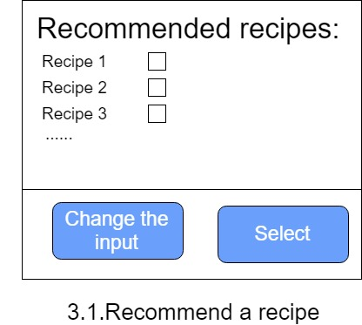
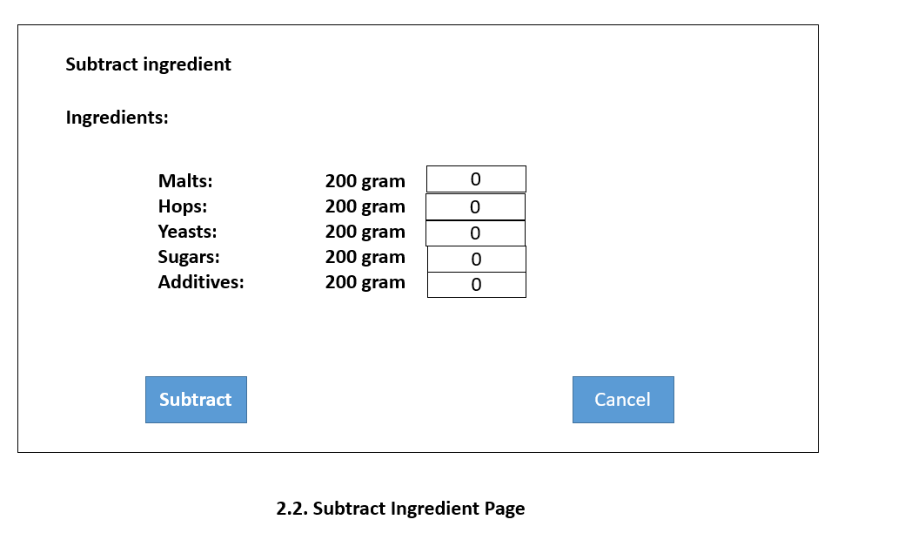

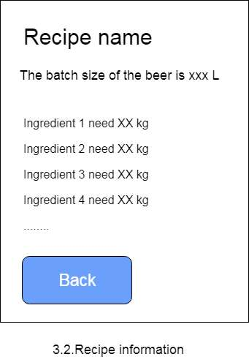

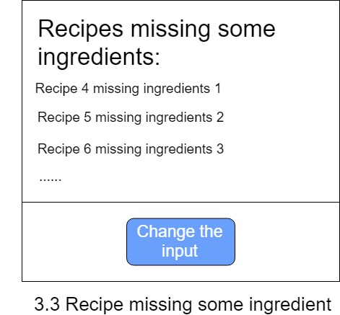
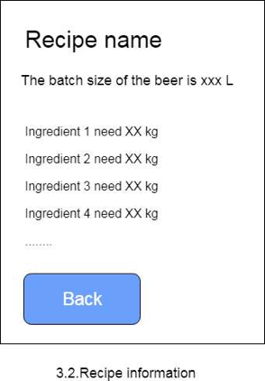

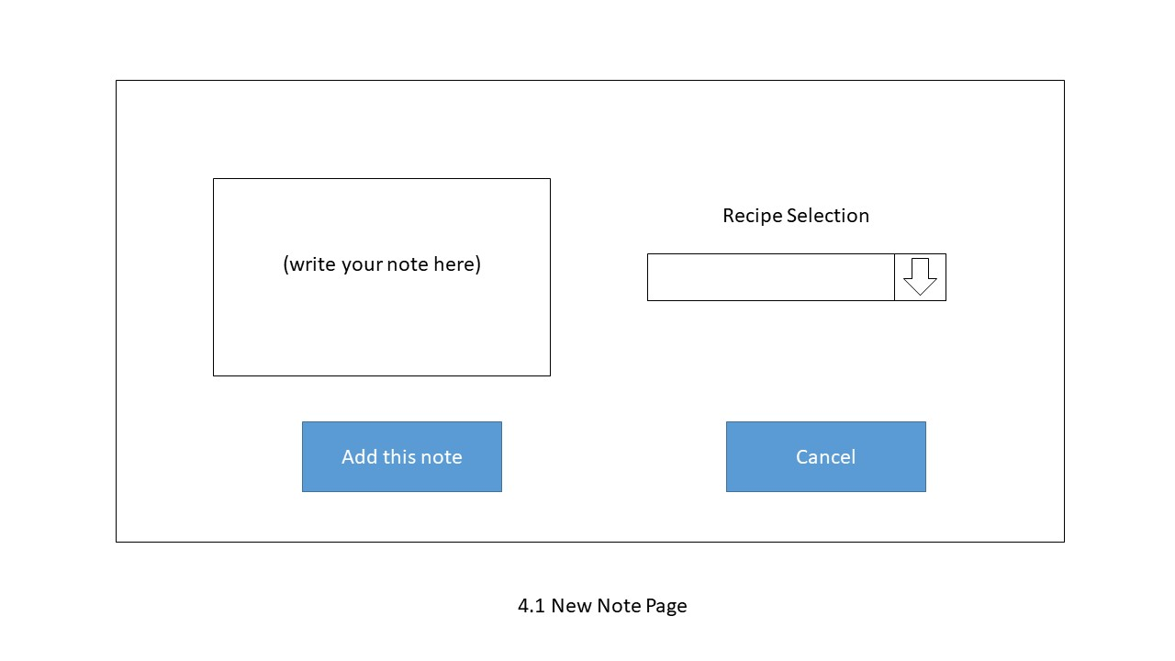
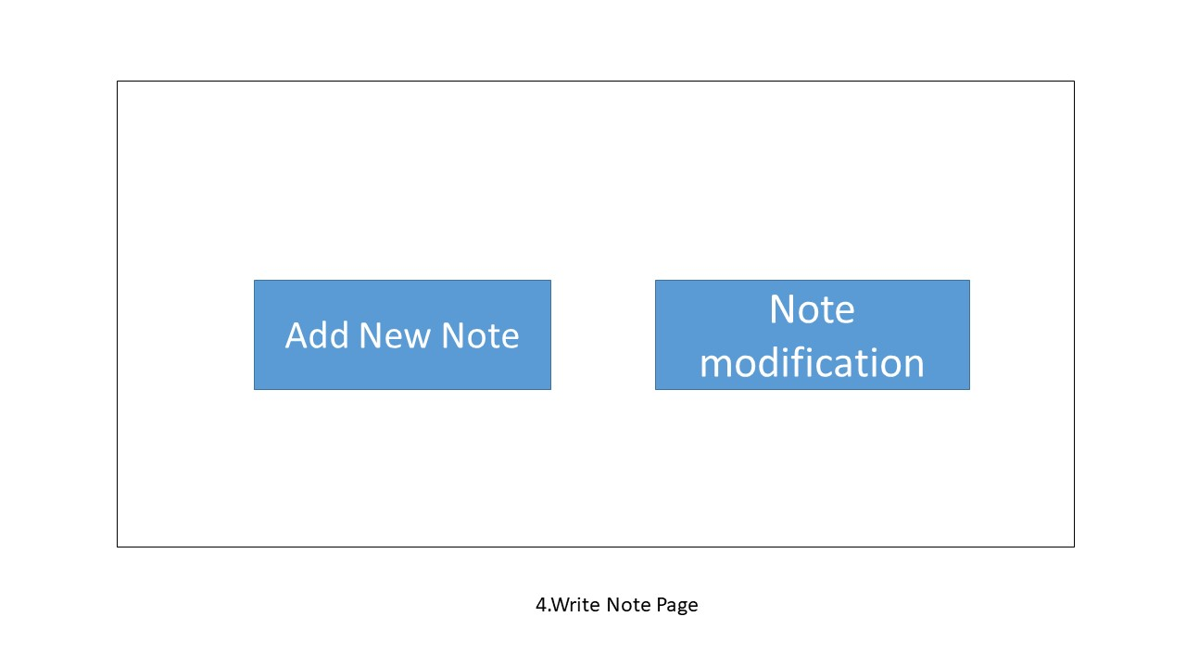

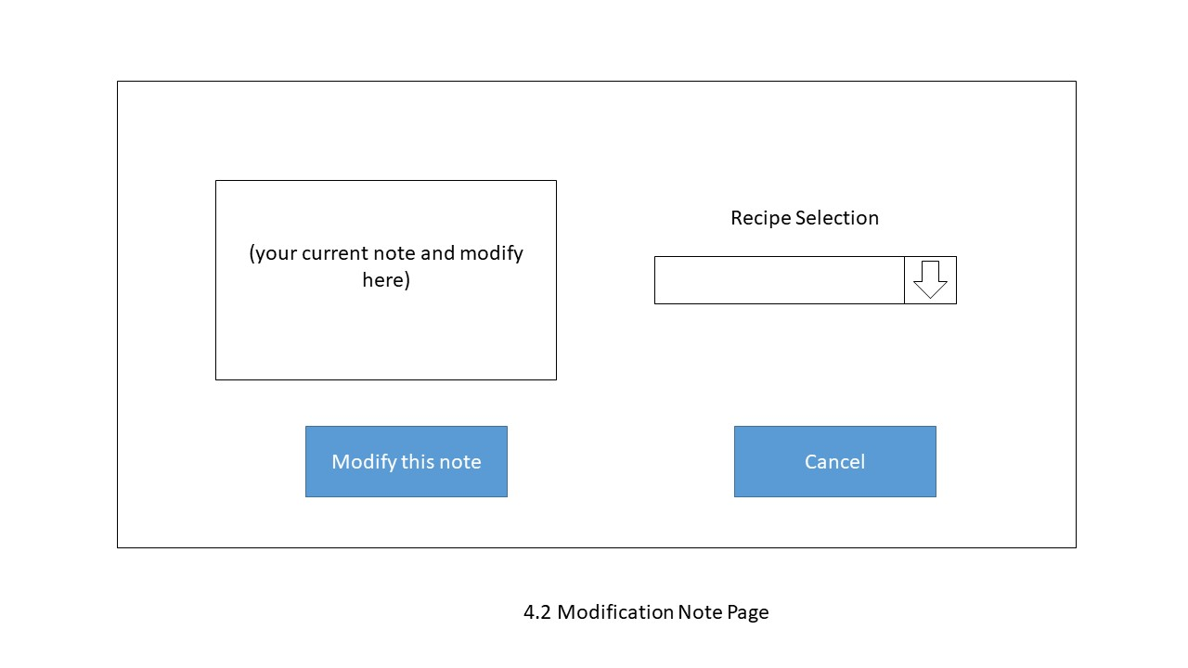

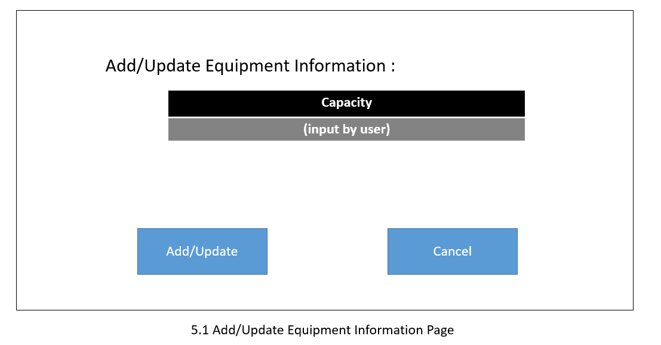

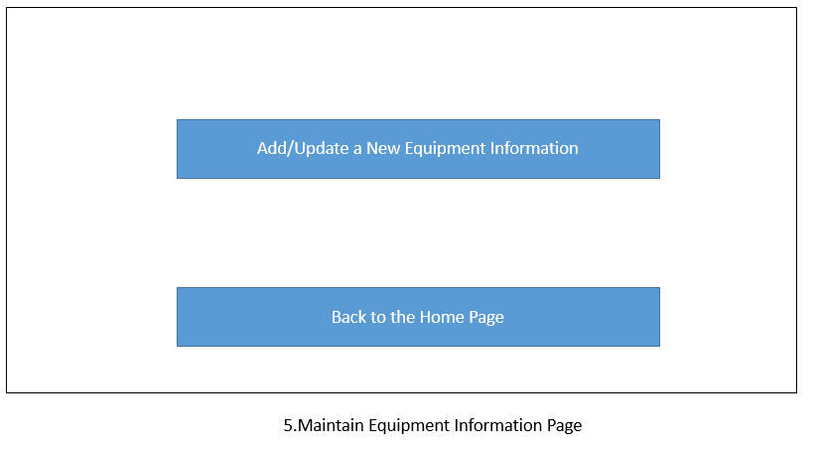

Hardware Interfaces
NONE

Software Interfaces
The application allows home brewers to maintain an organized database of their beer recipes. The application allows users to create, store and modify recipes, and later on delete them, if the user wishes to do so. If user want to use the feature of "what should I brew today?” the application can go through the recipes database to search.

Communications Interfaces
TBD

Other Nonfunctional Requirements

Performance Requirements
This application needs to transfer the data, for example when we use login our account, the application would transfer the data to the database and compare the data. In this case we require the application have a well performance in the data transfer. Make sure the data will not lose any things during the transfer. If there are miss some things during the transfer, we should send the data again. Which also apply in updating the data.

It also requires this application haves 1 sec response time form ask the data from the database.

Safety Requirements
This application requires a warning label to each recipe, it will tell the brewers all the announcements about this beer or wines, such as alcoholicity, and unsuitable for what people. Which can prevent some people who can’t drink, such as the people who have alcohol allergy, to drink those beers or wines.
This application also requires an alarm clock to tell the user when they should stop brewing and the expiration date.

Security Requirements
This application requires every user should have a user account to identification. The users can’t see other users’ recipes, except they share it to others.

And this application may require more user’s information, such as the location and phone number, that information should be keep in the database of sever, can’t use in any others way.

Software Quality Attributes

This application was required to object-oriented models. Then it can have the quality attributes of adaptability, maintainability, reusability, robustness and usability.

Other Requirements
TBD

Other Requirements
TBD

Appendix A: Glossary
NONE

Appendix B: Analysis Models

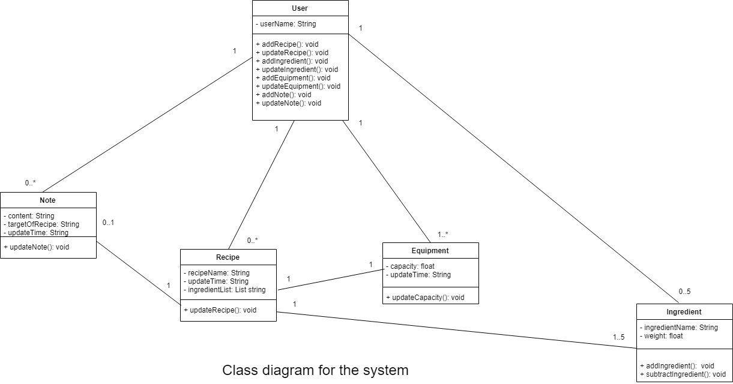

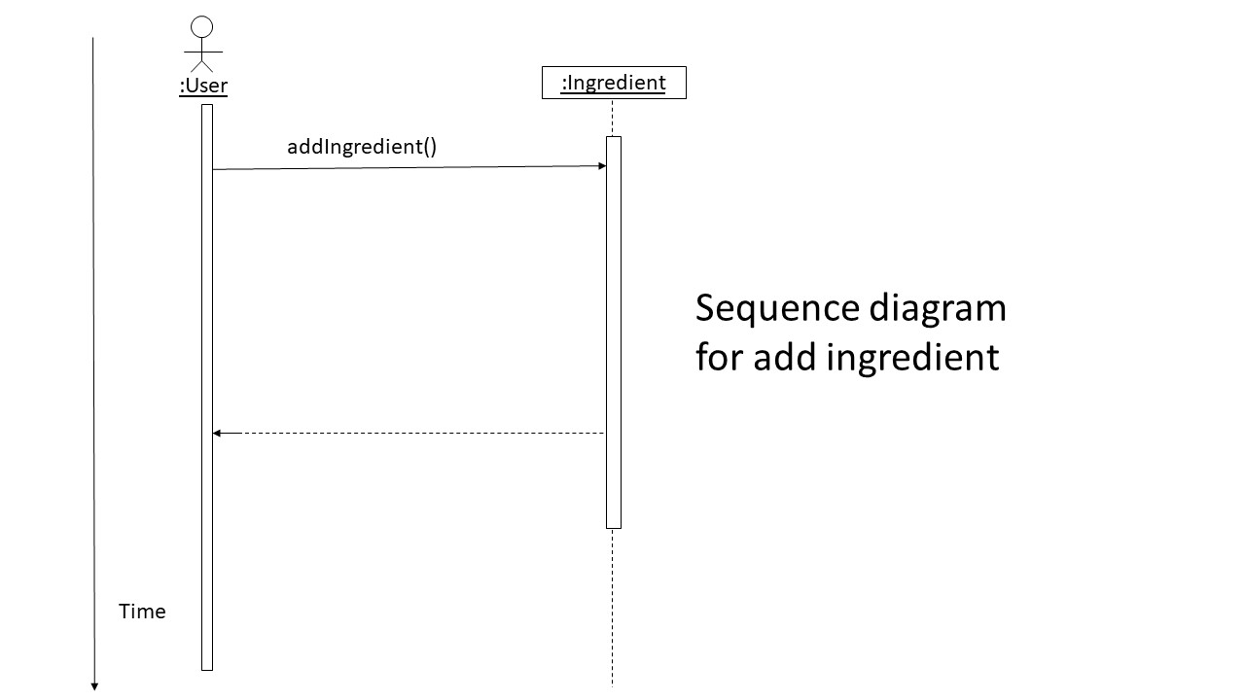

Appendix C: Issues List
NONE

